Chapter 2 – Quiz Mode & Learning Assessment
2.1 Introduction
The Quiz Mode and Learning Assessment module is designed to enhance anatomy learning through interactive assessment techniques. This module allows users to evaluate their understanding of anatomical structures and body systems using different question formats while tracking their learning progress over time.
The module provides immediate feedback, score calculation, progress monitoring, and performance analysis, creating an engaging educational experience.

2.2 Functional Requirements
- The system shall:
- Allow users to start a quiz.
- Display anatomy-related questions.
- Support Multiple Choice Questions (MCQ).
- Support Identify-the-Part Questions.
- Support Clinical Scenario Questions.
- Calculate scores automatically.
- Display feedback after each answer.
- Generate a quiz results page.
- Track user progress.
- Store quizzes.

2.3 Non-Functional Requirements
1) Easy-to-use interface.
2) Fast response time.
3) Reliable performance.
4) Secure data storage.
5) Scalability for future improvements.
6) Responsive user interface.

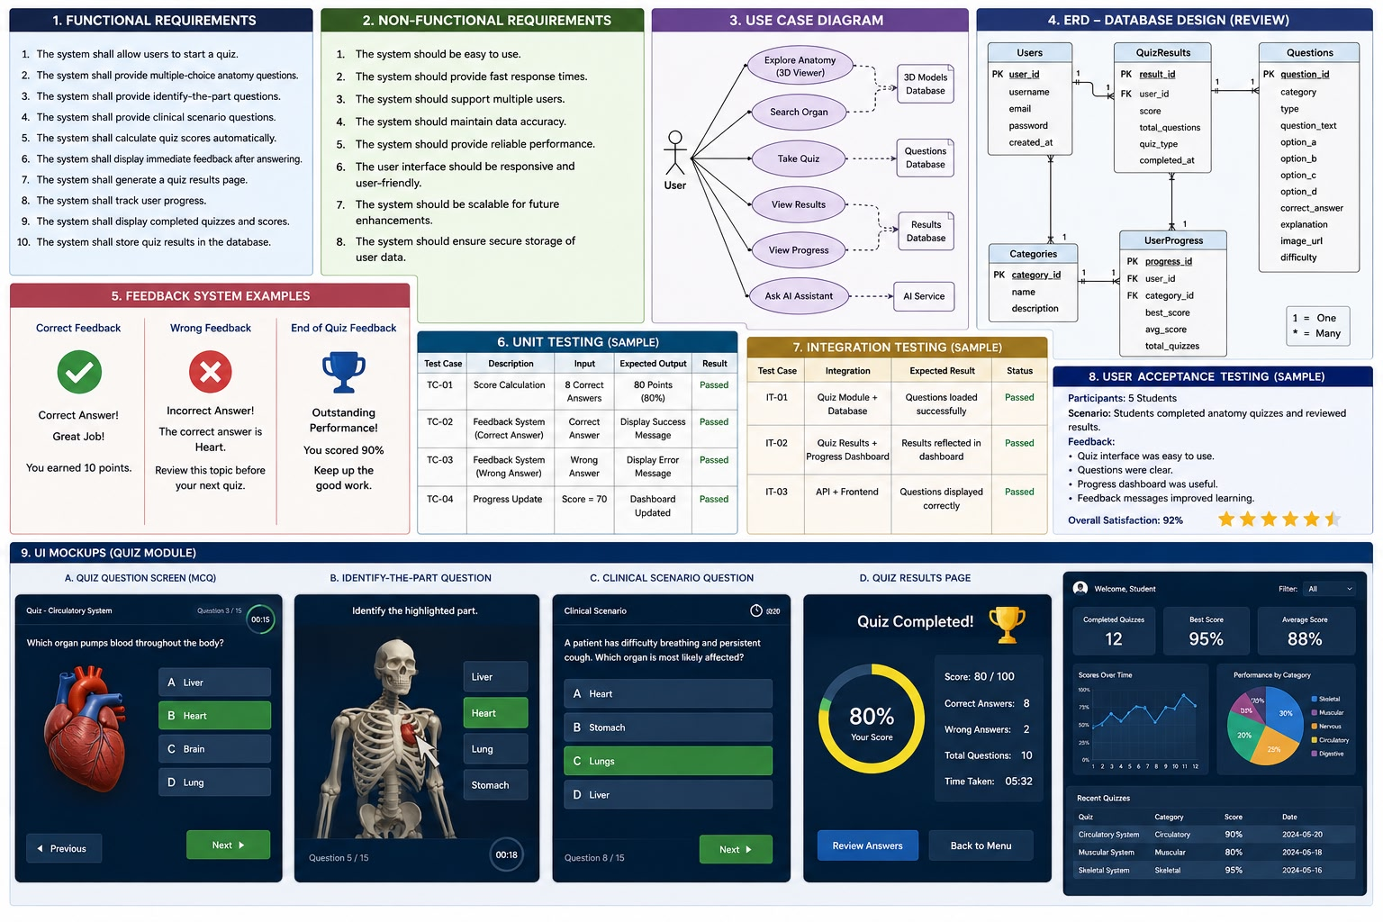

2.4 Quiz Database Design
The quiz module requires a database to store questions and quiz results.
Questions Table
- Question ID
- Question Text
- Category
- Difficulty Level
- Question Type
- Correct Answer
Quiz Results Table
- Result ID
- User ID
- Score
- Quiz Date
Users Table
- User ID
- Username
- Email

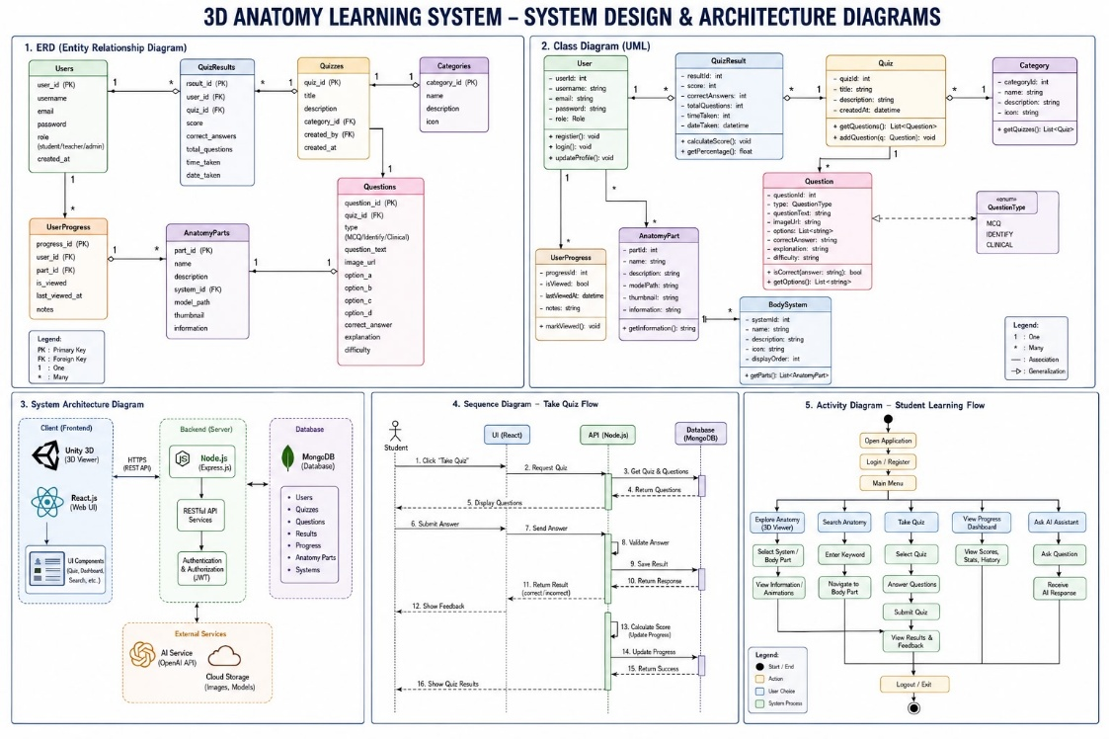
2.5 Question Categories
The quiz questions are organized into the following categories:
Skeletal System
- Skull
- Femur
- Tibia
- Radius
Muscular System
- Biceps
- Triceps
- Deltoid
Nervous System
- Brain
- Spinal Cord
- Cerebellum
Circulatory System
- Heart
- Arteries
- Veins

2.6 Multiple Choice Questions
The user selects the correct answer from multiple options.
Example:
Question:
Which organ pumps blood through the body?
A. Liver
B. Heart
C. Kidney
D. Lung
Correct Answer:Heart

2.7 Identify-the-Part Questions
The user identifies a highlighted anatomical structure from the 3D model.
Example:
Identify the highlighted organ.
Options:
- Heart
- Lung
- Liver
- Kidney

2.8 Clinical Scenario Questions
The user answers anatomy questions based on real-life medical situations.
Example:
A patient cannot properly filter waste from the blood.
Which organ is affected?
A. Heart
B. Lung
C. Kidney
D. Liver
Correct Answer:
Kidney.

2.9 Score Calculation System

The system automatically calculates quiz scores.
Scoring Method:
- Correct Answer = 10 Points
- Wrong Answer = 0 Points
- Final Score = Number of Correct Answers × 10

2.10 Feedback System
The system provides immediate feedback.
Correct Answer Feedback:
- Correct Answer!
- Great Job!
- You earned 10 points.
Incorrect Answer Feedback:
- Incorrect Answer!
- Correct Answer: Heart
- Review this topic before continuing.

2.11 Quiz Results Page
The results page displays:
- Final Score
- Correct Answers
- Wrong Answers
- Percentage
Example:
- Score: 80%
- Correct Answers: 8
- Wrong Answers: 2

2.12 Progress Dashboard
The dashboard tracks user performance.
Displayed Information:
- Completed Quizzes
- Best Score
- Average Score
- Category Performance
Example:
- Completed Quizzes: 12
- Best Score: 95%
- Average Score: 88%

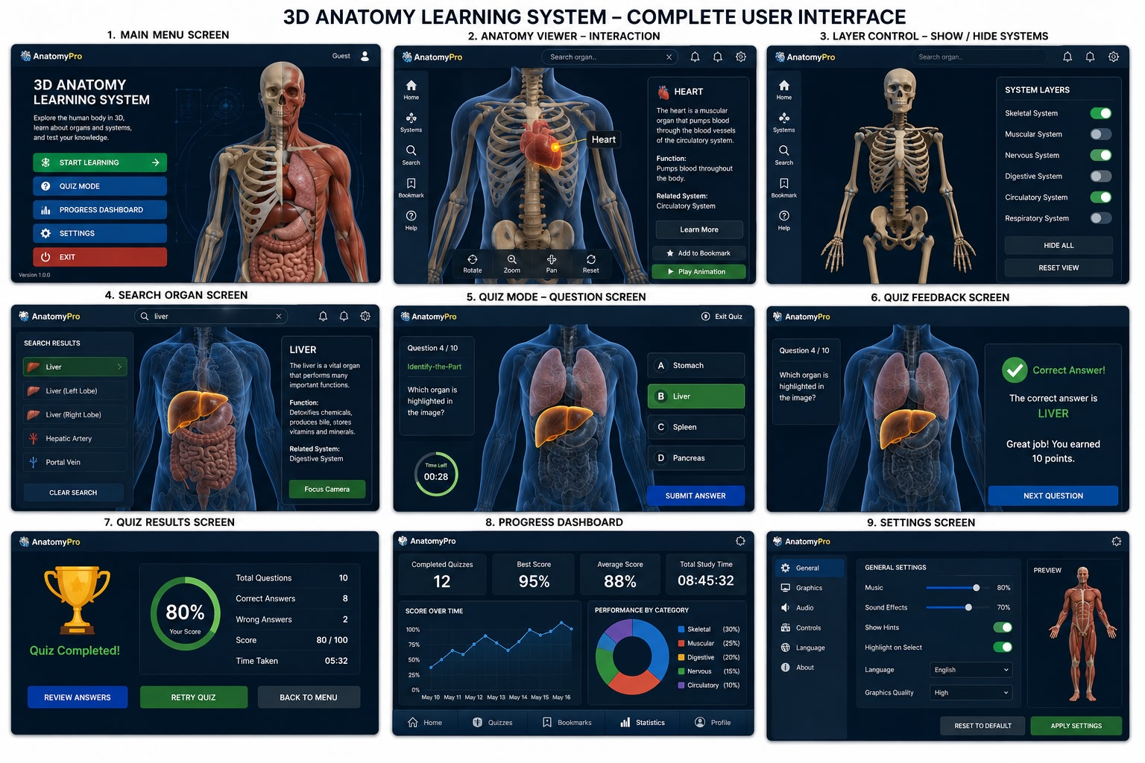

2.13 Use Case Design
The quiz module supports the following use cases:
- Take Quiz
- Answer Questions
- Receive Feedback
- View Results
- View Progress

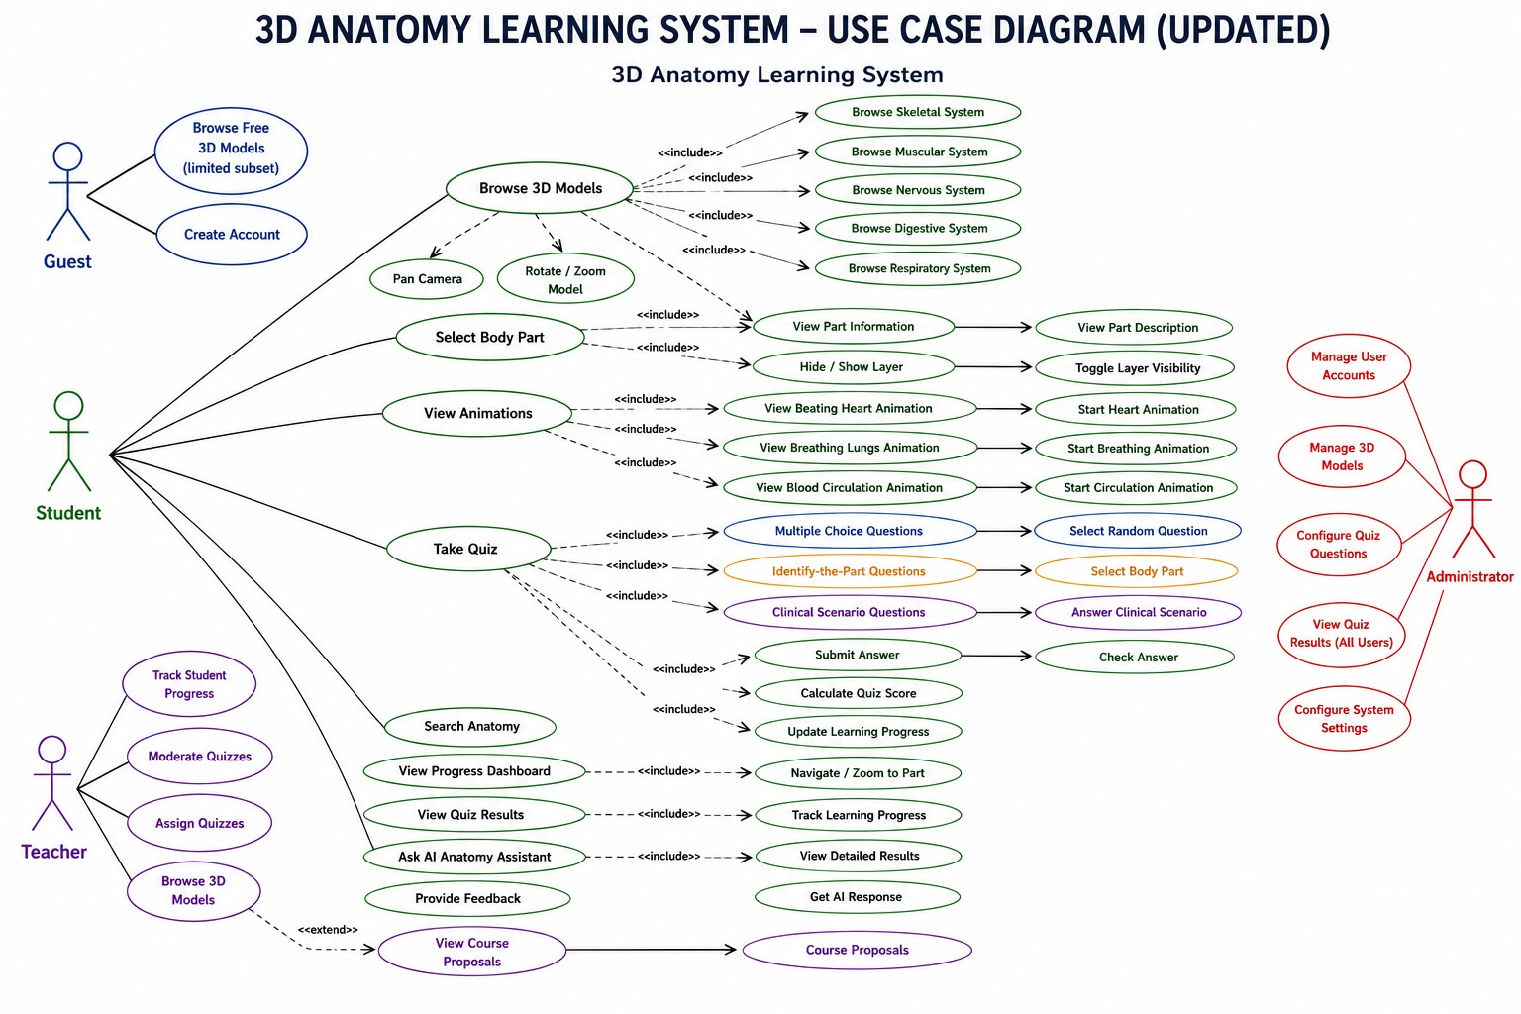

2.14 Testing
Unit Testing
Tests performed:
- Score Calculation Test
- Feedback System Test
- Progress Tracking Test

- Integration Testing
Tests performed:
- Quiz Module + Database
- Quiz Results + Dashboard

- User Acceptance Testing
Students evaluated the system and confirmed:
- Easy navigation
- Clear questions
- Accurate scoring
- Helpful feedback
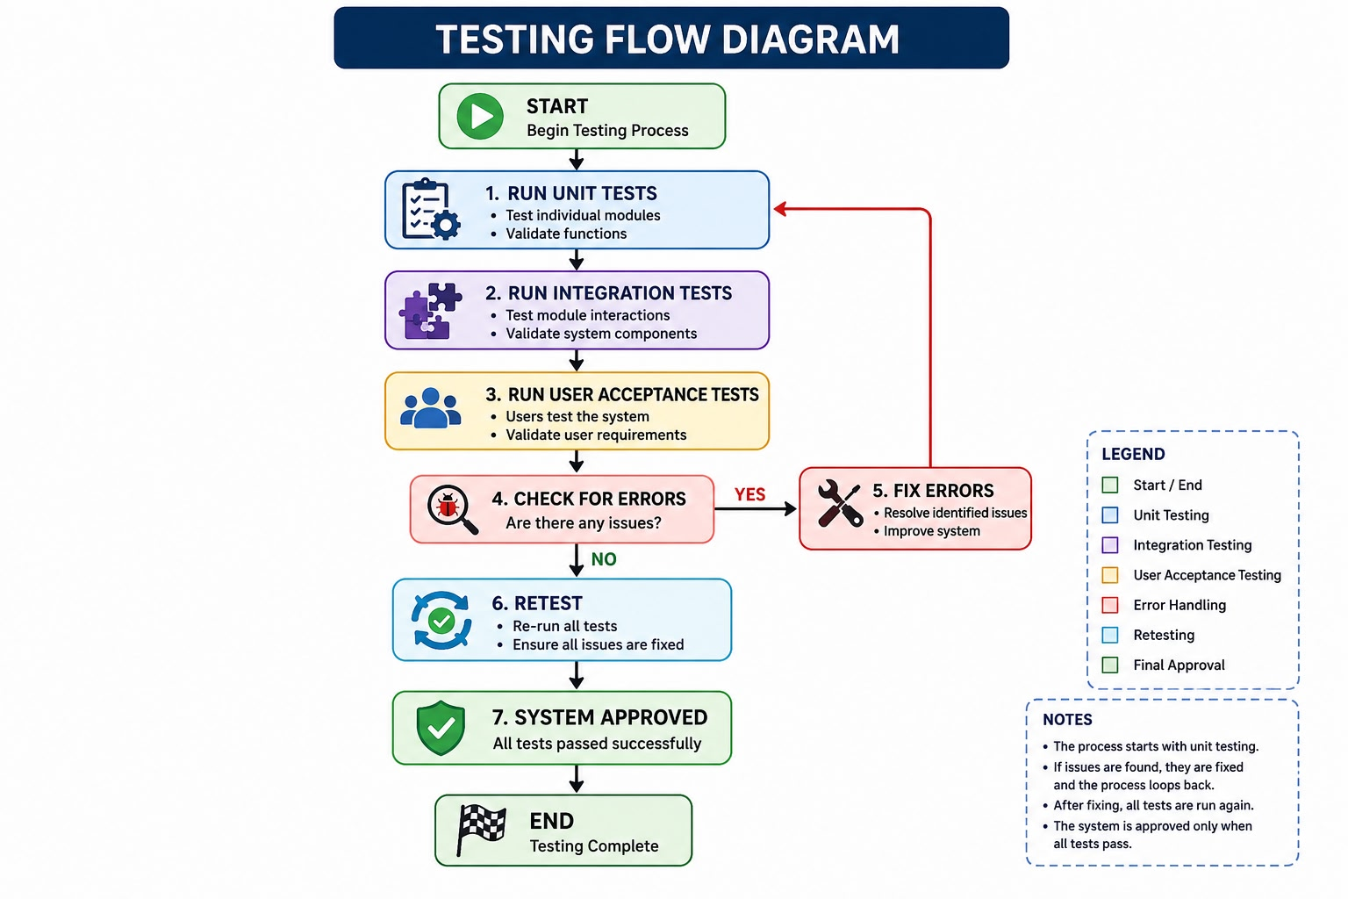

2.15 Literature Review
Several anatomy learning systems were reviewed:
- Visible Body
- BioDigital Human
- Complete Anatomy
These systems provide advanced anatomy visualization but have limited integration between quizzes, progress tracking, search functionality, and AI tutoring.

The proposed 3D Anatomy Learning System integrates:
- Interactive 3D Visualization
- Quiz-Based Assessment
- Organ Search
- AI Anatomy Assistant
This combination provides a more complete educational experience.

Deliverables
- Quiz Module
- Score System
- Quiz Results Page
- Progress Dashboard Logic
- Literature Review
- Requirements Analysis
- Use Case Design
- ERD Review
- Testing Documentation

